Families Creating Accounts in a New State
Before You Start
If a family logs in to their account and is signed into a different institution from what they prefer, they can choose to join another institution. Families may need to associate their account with a new state if they have moved or selected an incorrect institution at the time they created their account.
Steps  1. Login to your Family account.  2. Click on the Family Profile button.  3. Click “Join another institution” in the bottom left corner. | Screenshots  (Screen appearance may vary per state)  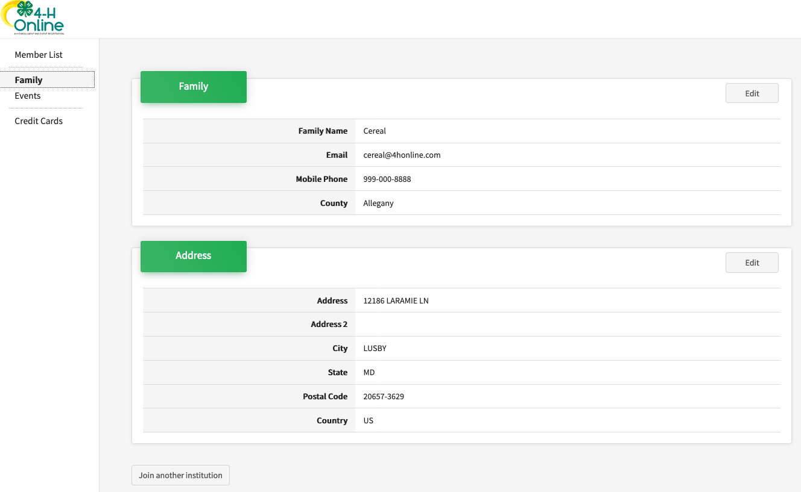
- Click the Confirm button. | 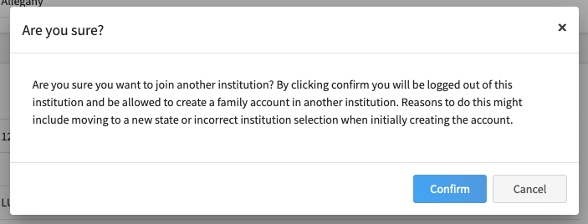
- Click the blue “Add another profile button. | 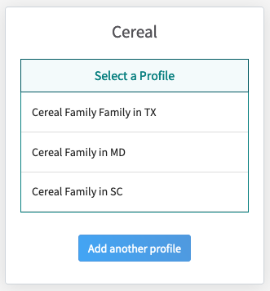
- Select the new state, institution, and county and click Save.  - Continue with the enrollment process in the new state. | 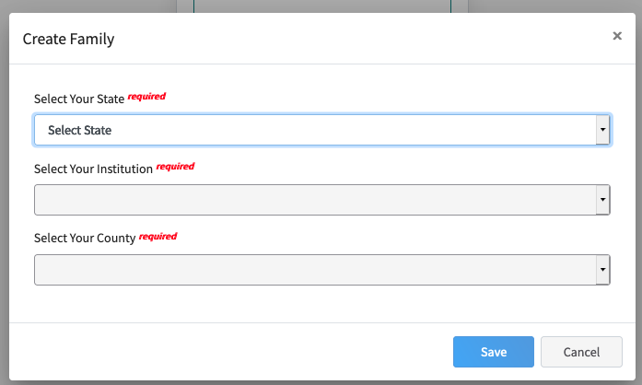
Tips
- The family may use the same USPS address when creating an account in a new institution.
- Families may quickly switch between their institutions by clicking on their name in the upper-right corner and selecting “Change Institution”.

